THE PREDICTOR CARDS.
For this trick you need a set of four square cards with numbers on them as shown below. Three of the cards have sections that need cutting out. The last “master” card has numbers on both sides. Cut out the double square and fold it down the middle.
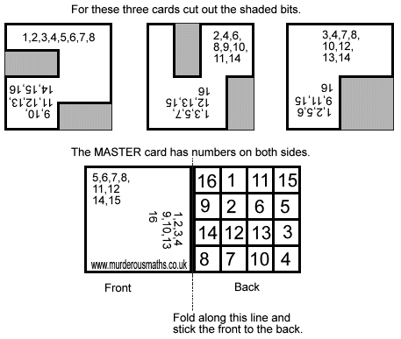
Ask a friend to choose a number between 1-16. Pass the cards over with the master card front side up. Your friend has to stack the cards on top of each other with the chosen number the right way up on each card. The Master card goes on top.
Oh boy, this is so cute… turn the pile over and you can see your friend’s chosen number through the little hole at the back!
© Kjartan Poskitt 2009

